COMPUTER PROGRAMMING

BĂNESARU ANDREEA-BIANCA

Introduction

For this project I choose to write a program related to the NEWBORN bank deposit offer. This offer is dedicated to saving for children’s studies which provides a preferential interest rate on the 1000th day after its establishment.

Requirement:

Calculate the 1000th day which correspond for the introduced date, if it is a valid one.

Description of the program in natural language

The program displays a menu and asks the user to introduce the year, month and day for which the user wants to know the 1000th day for the preferential interest rate. The program will calculate the date corresponding to the respective day.

The program will check if the date is a valid one.

* If the date is valid, then the program will calculate the 1000th date from the introduced date taking into consideration the leap years.
* If the date is not valid, the program will display a message through which assures the user that the date in not all right.

If the date is a valid one, the program will verify if the year introduced is a leap one. Next it will verify in order which is the next day, month and year. Then each day will be added until the 1000th day is reached. Finally it displays the 1000th day.

The  **is_leap_year()** function verifies if the year is a leap one.

The **add_day()** function verifies in order which is the next day, month, year.

The  **skip_days()**  function adds each day until the 1000th one.

The **date_validation()** function checks if the date is a valid one.

The  **print_date()** displays the date calculated after 1000 days.

The  **main()** function displays the menu for the user introduce year, month and day.

Workflow for each function

Function that checks if the year is a leap one

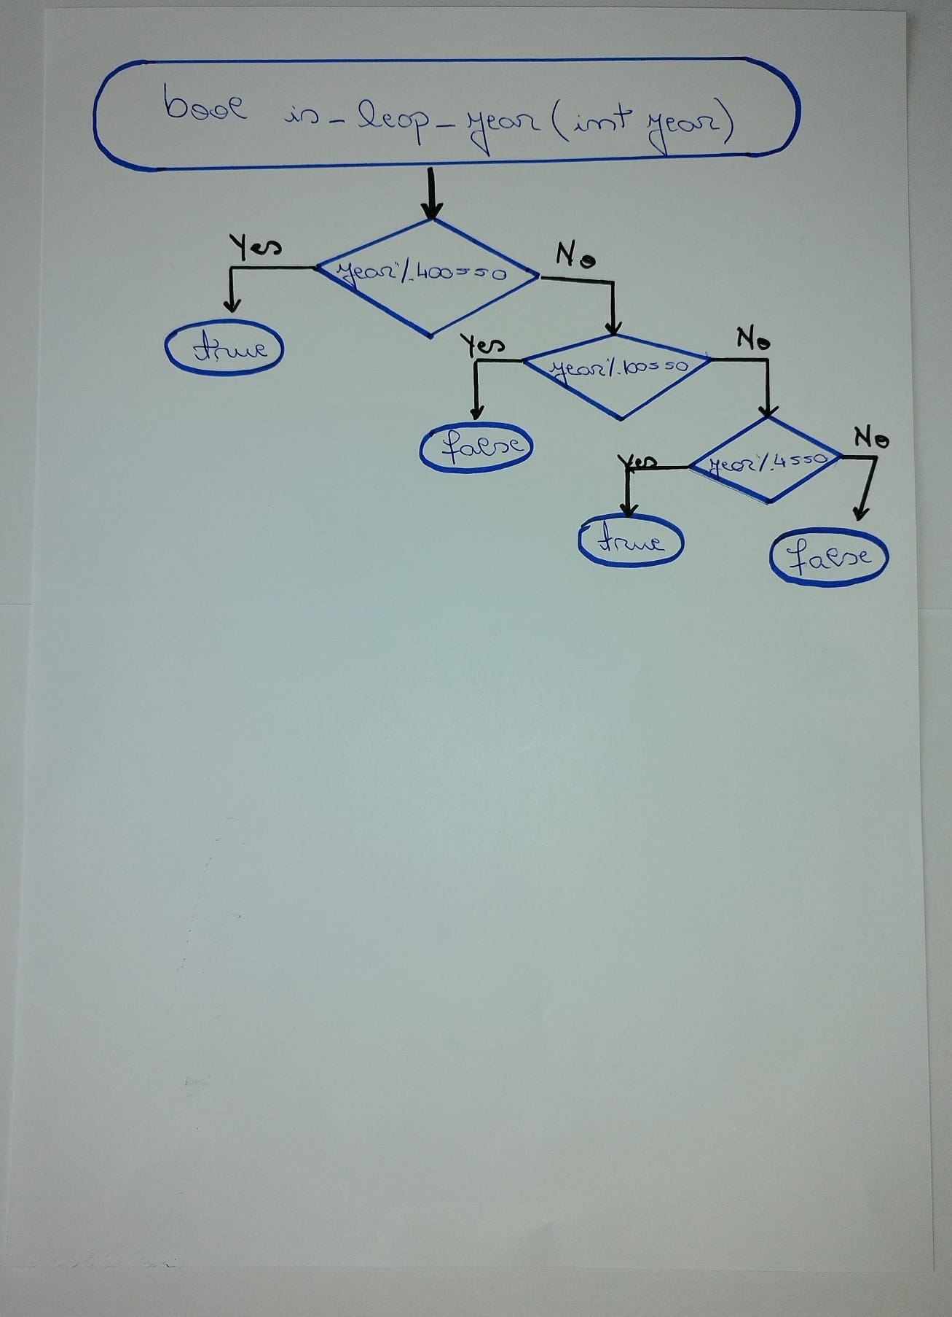

Function that verifies in order which is the next day, month, year

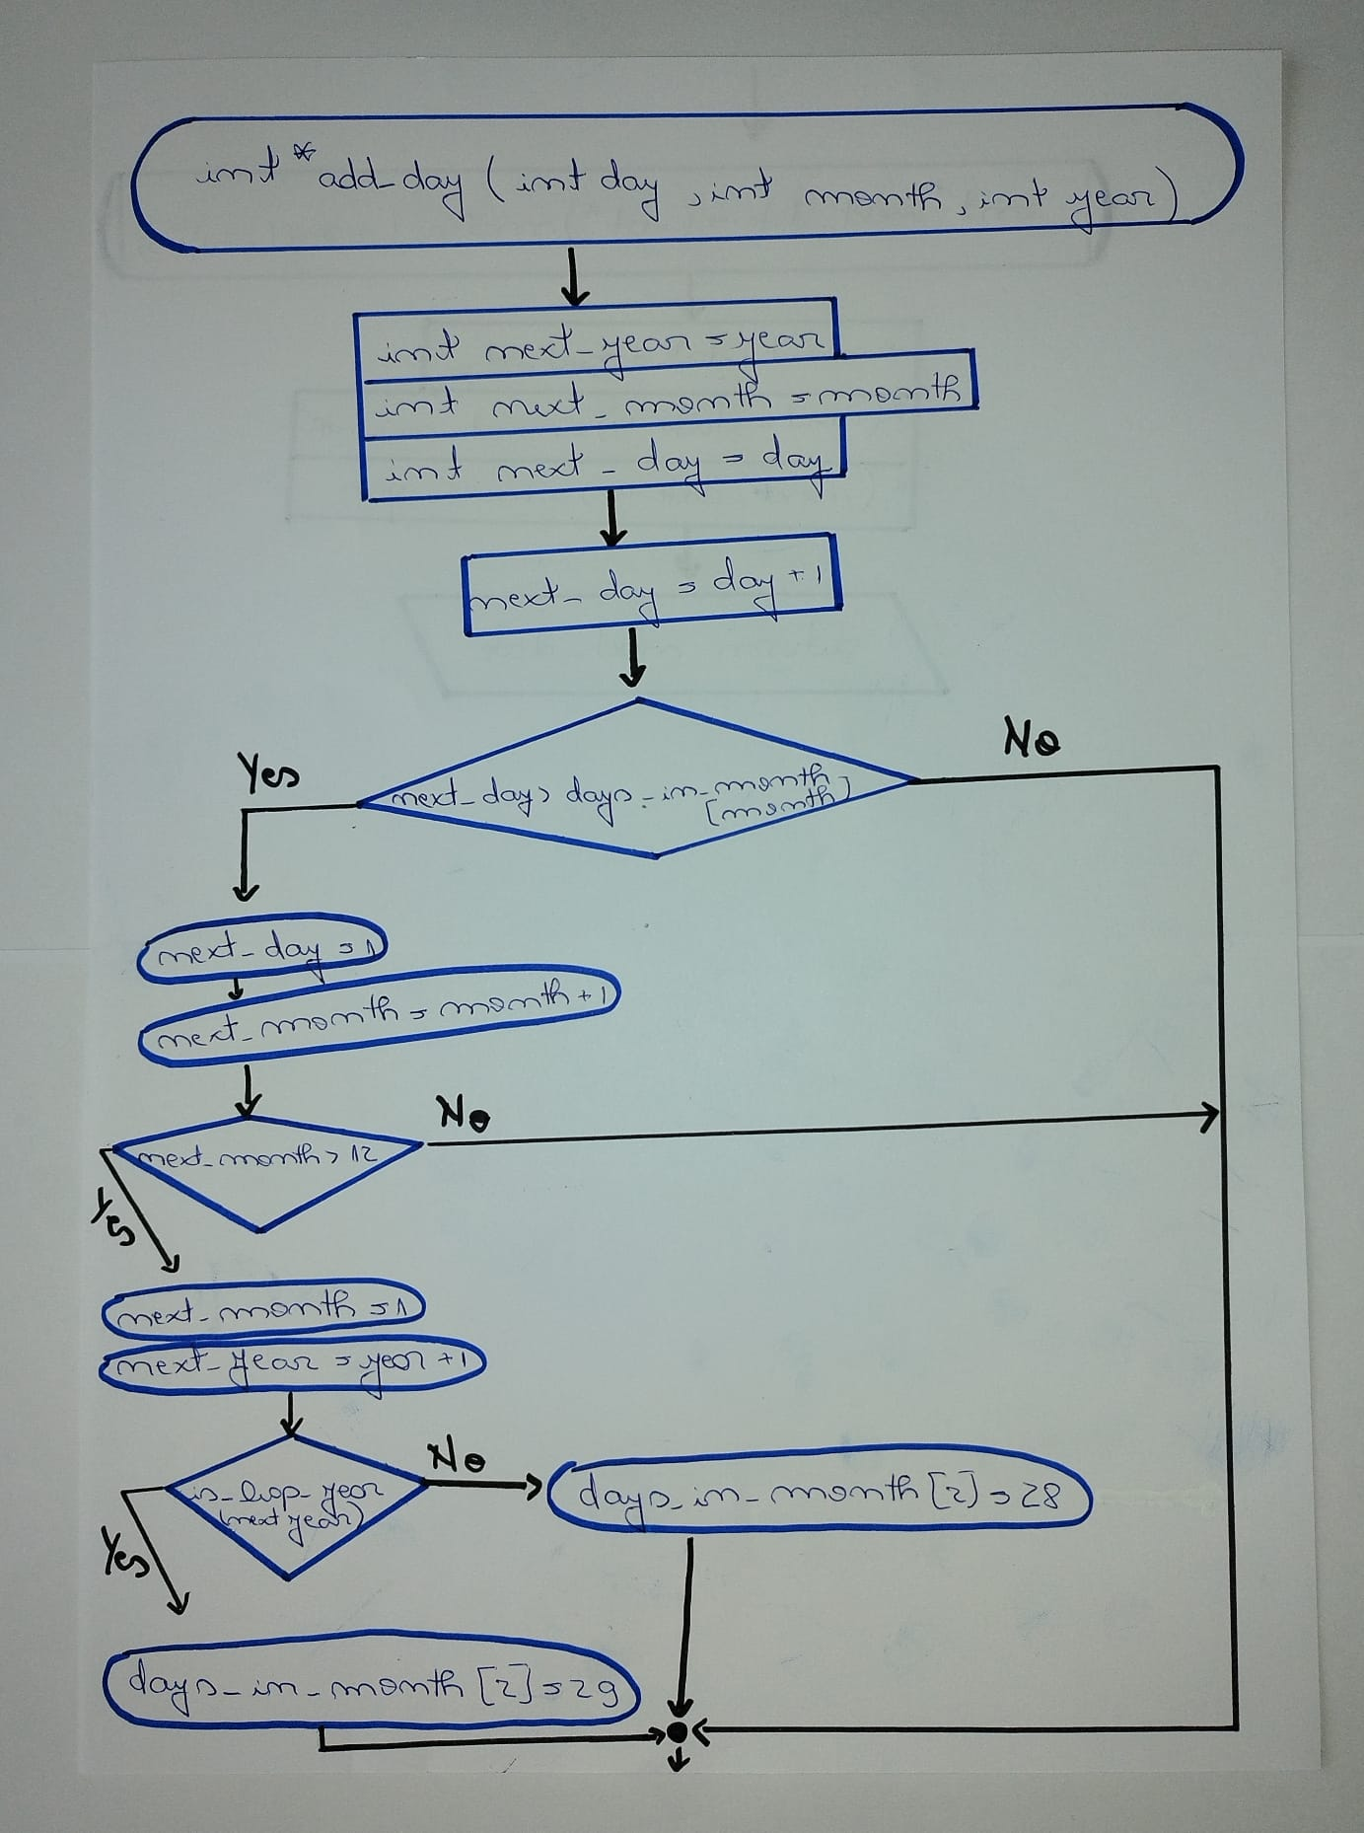

Function that verifies in order which is the next day, month, year

(continuation)

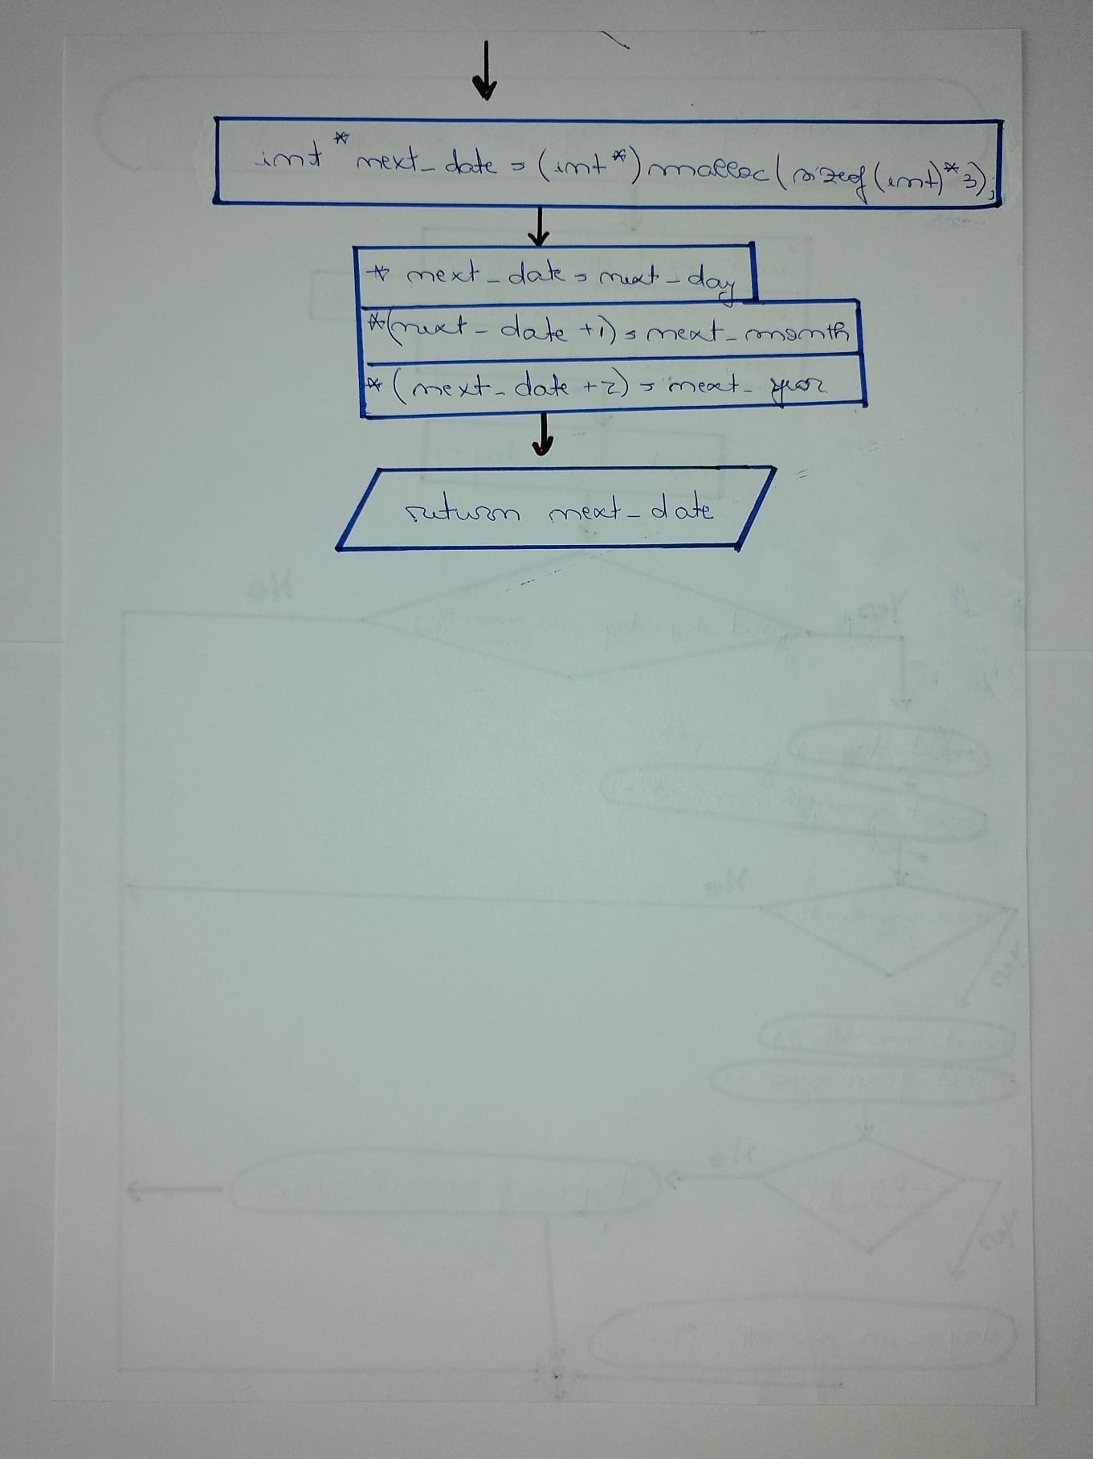

Function that adds each day until the 1000th one

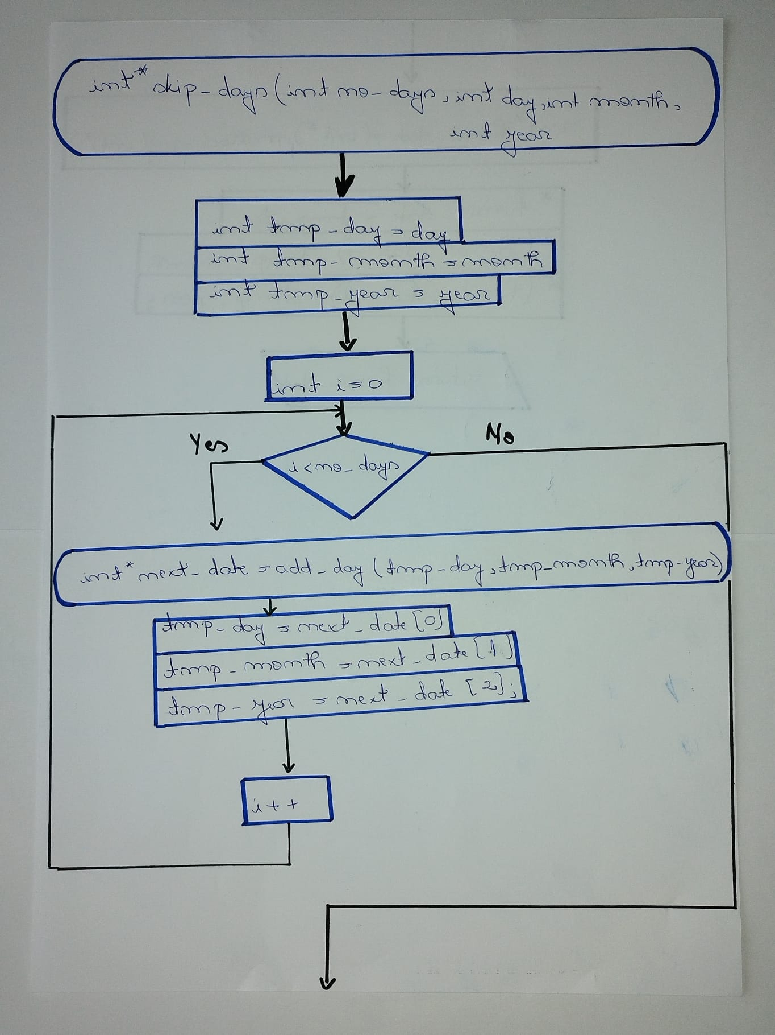

Function that adds each day until the 1000th one

(continuation)

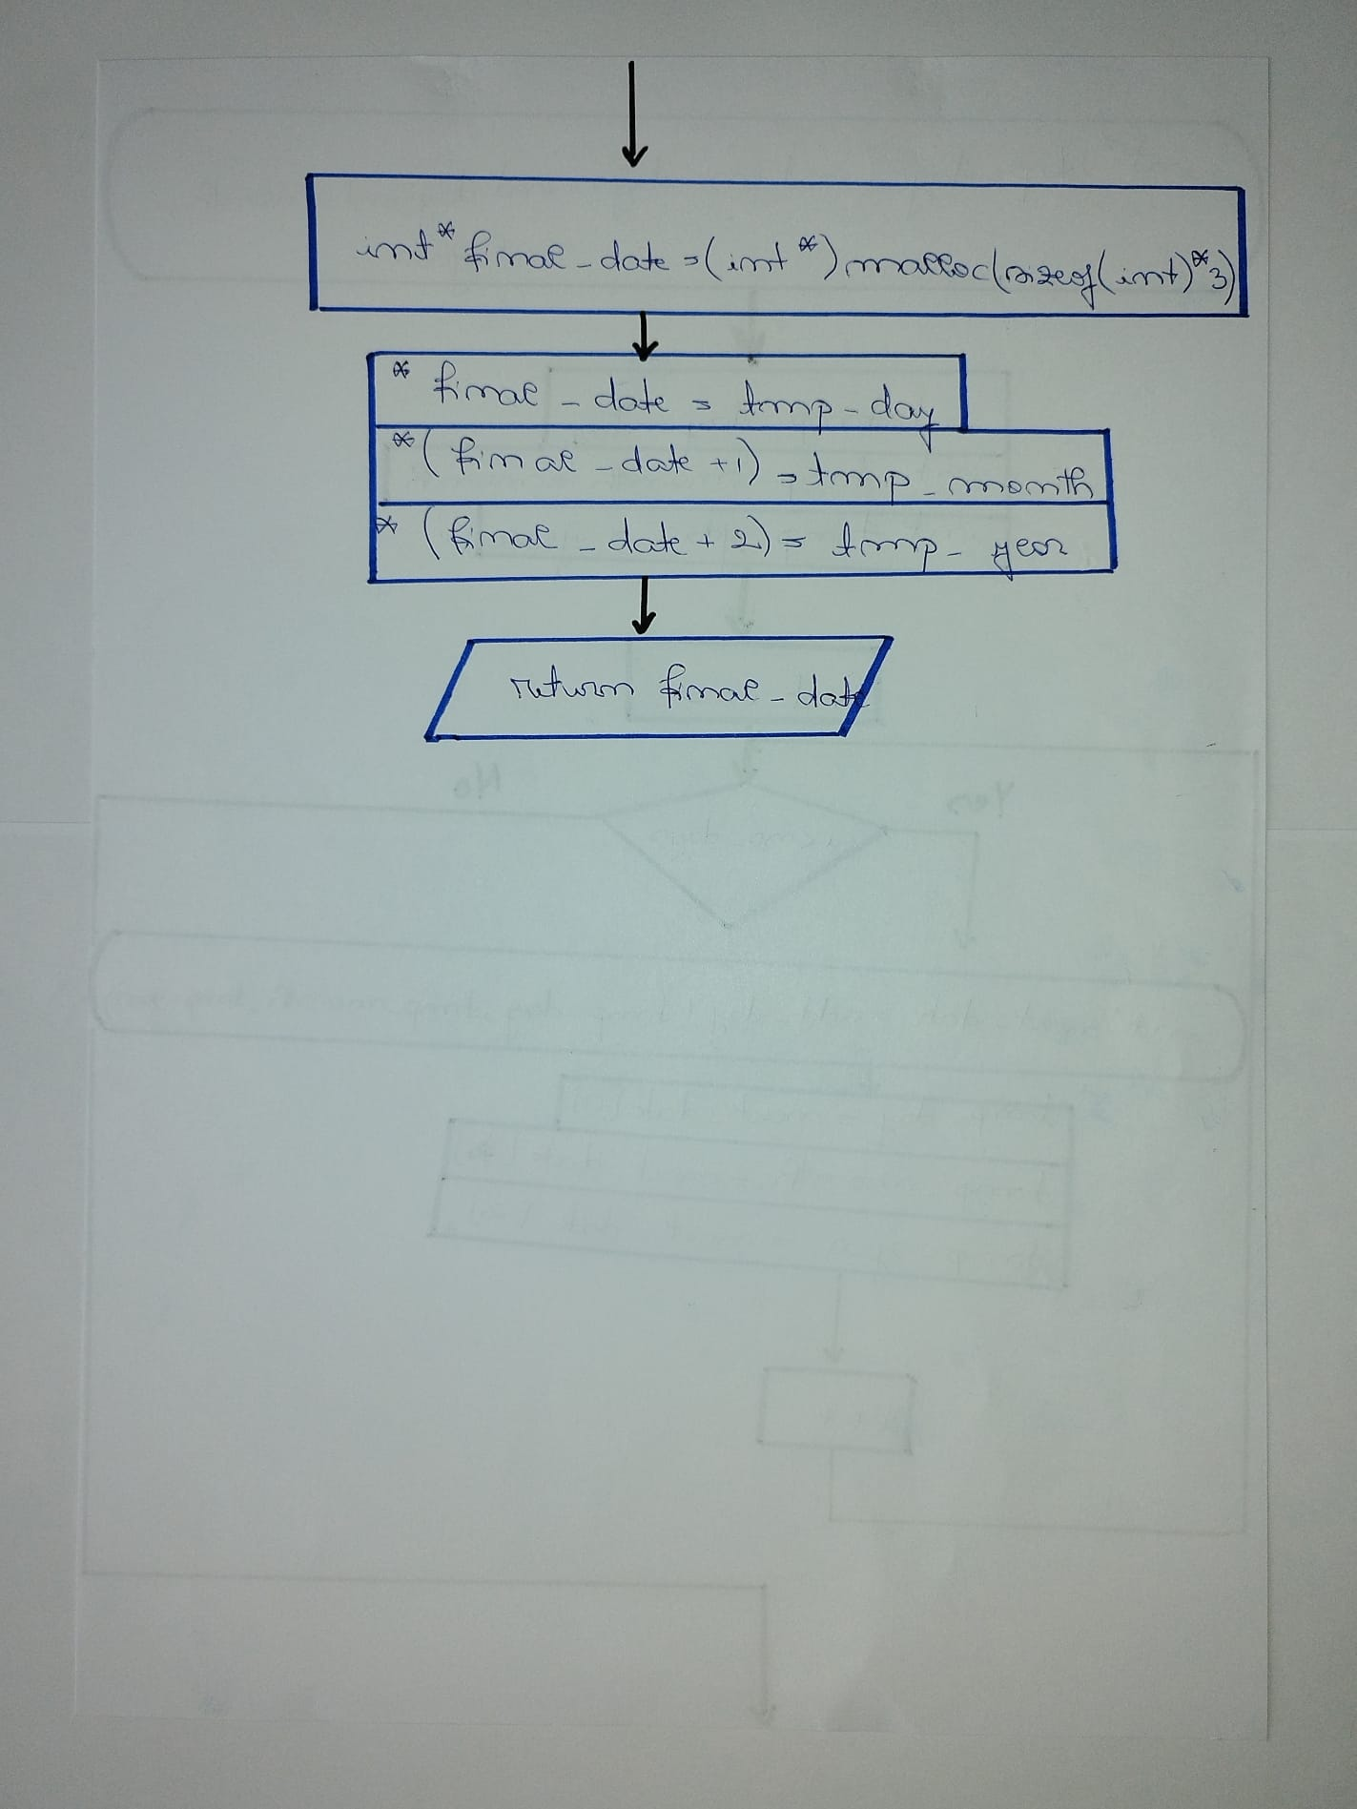

Function that checks if the date is a valid one

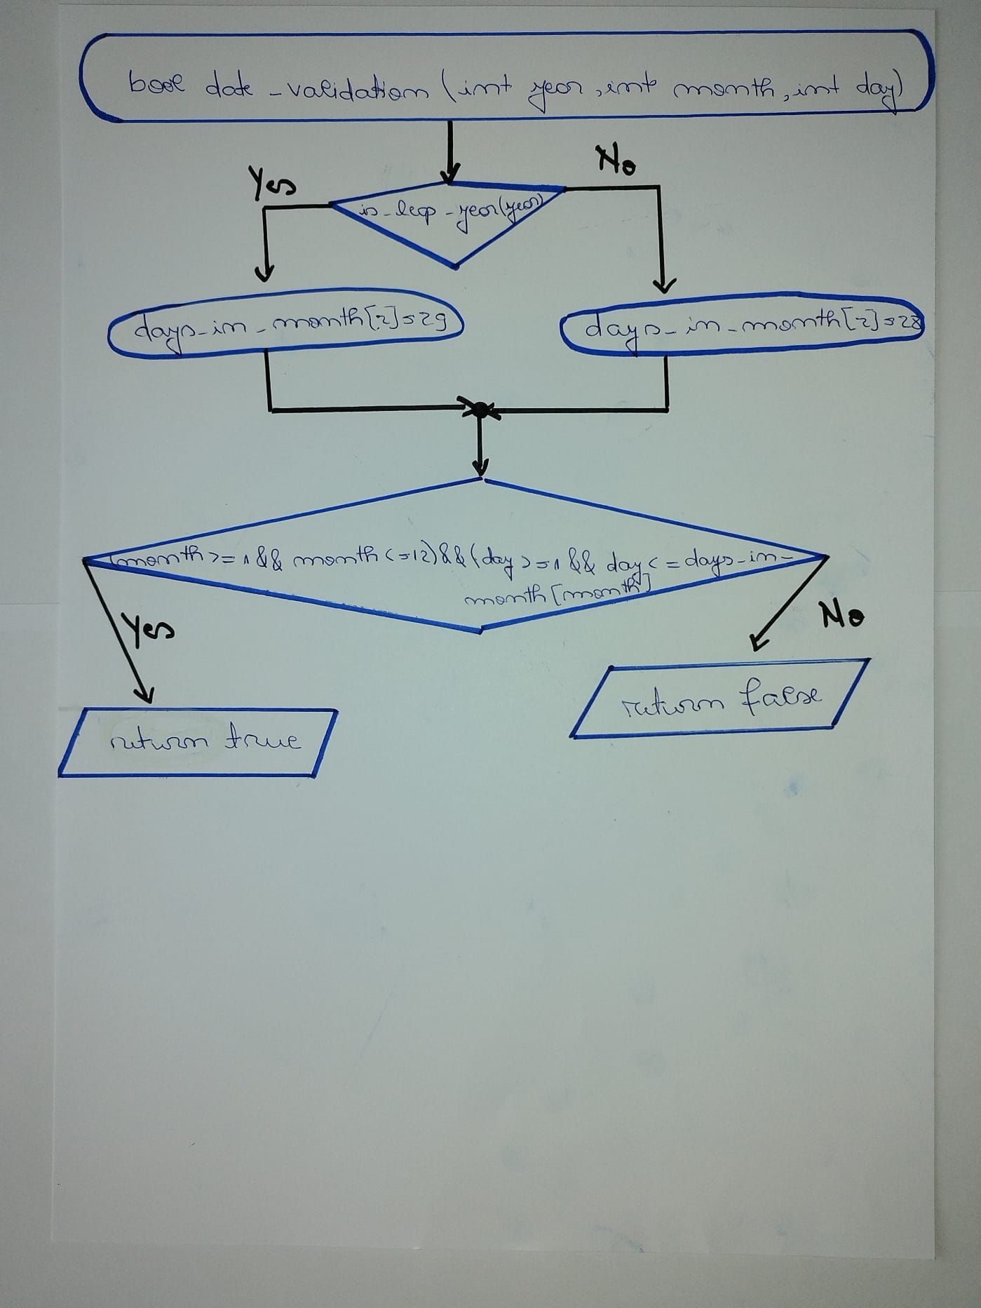

Function that displays the date calculated after 1000 days

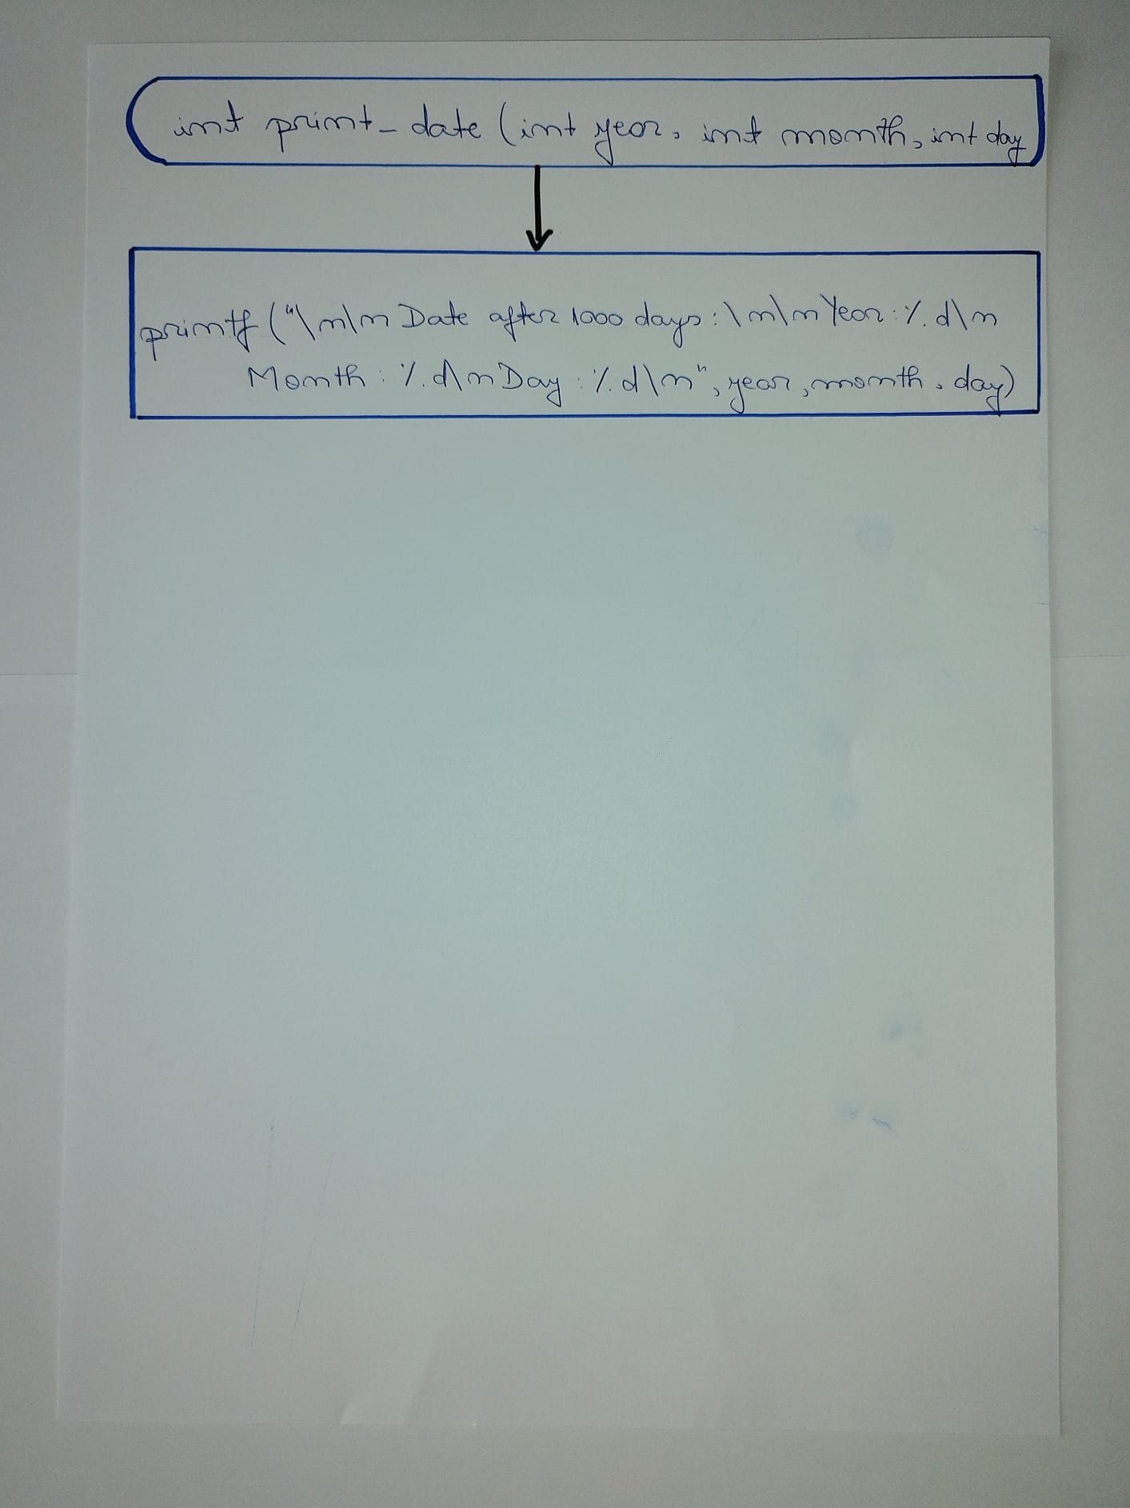

Main function

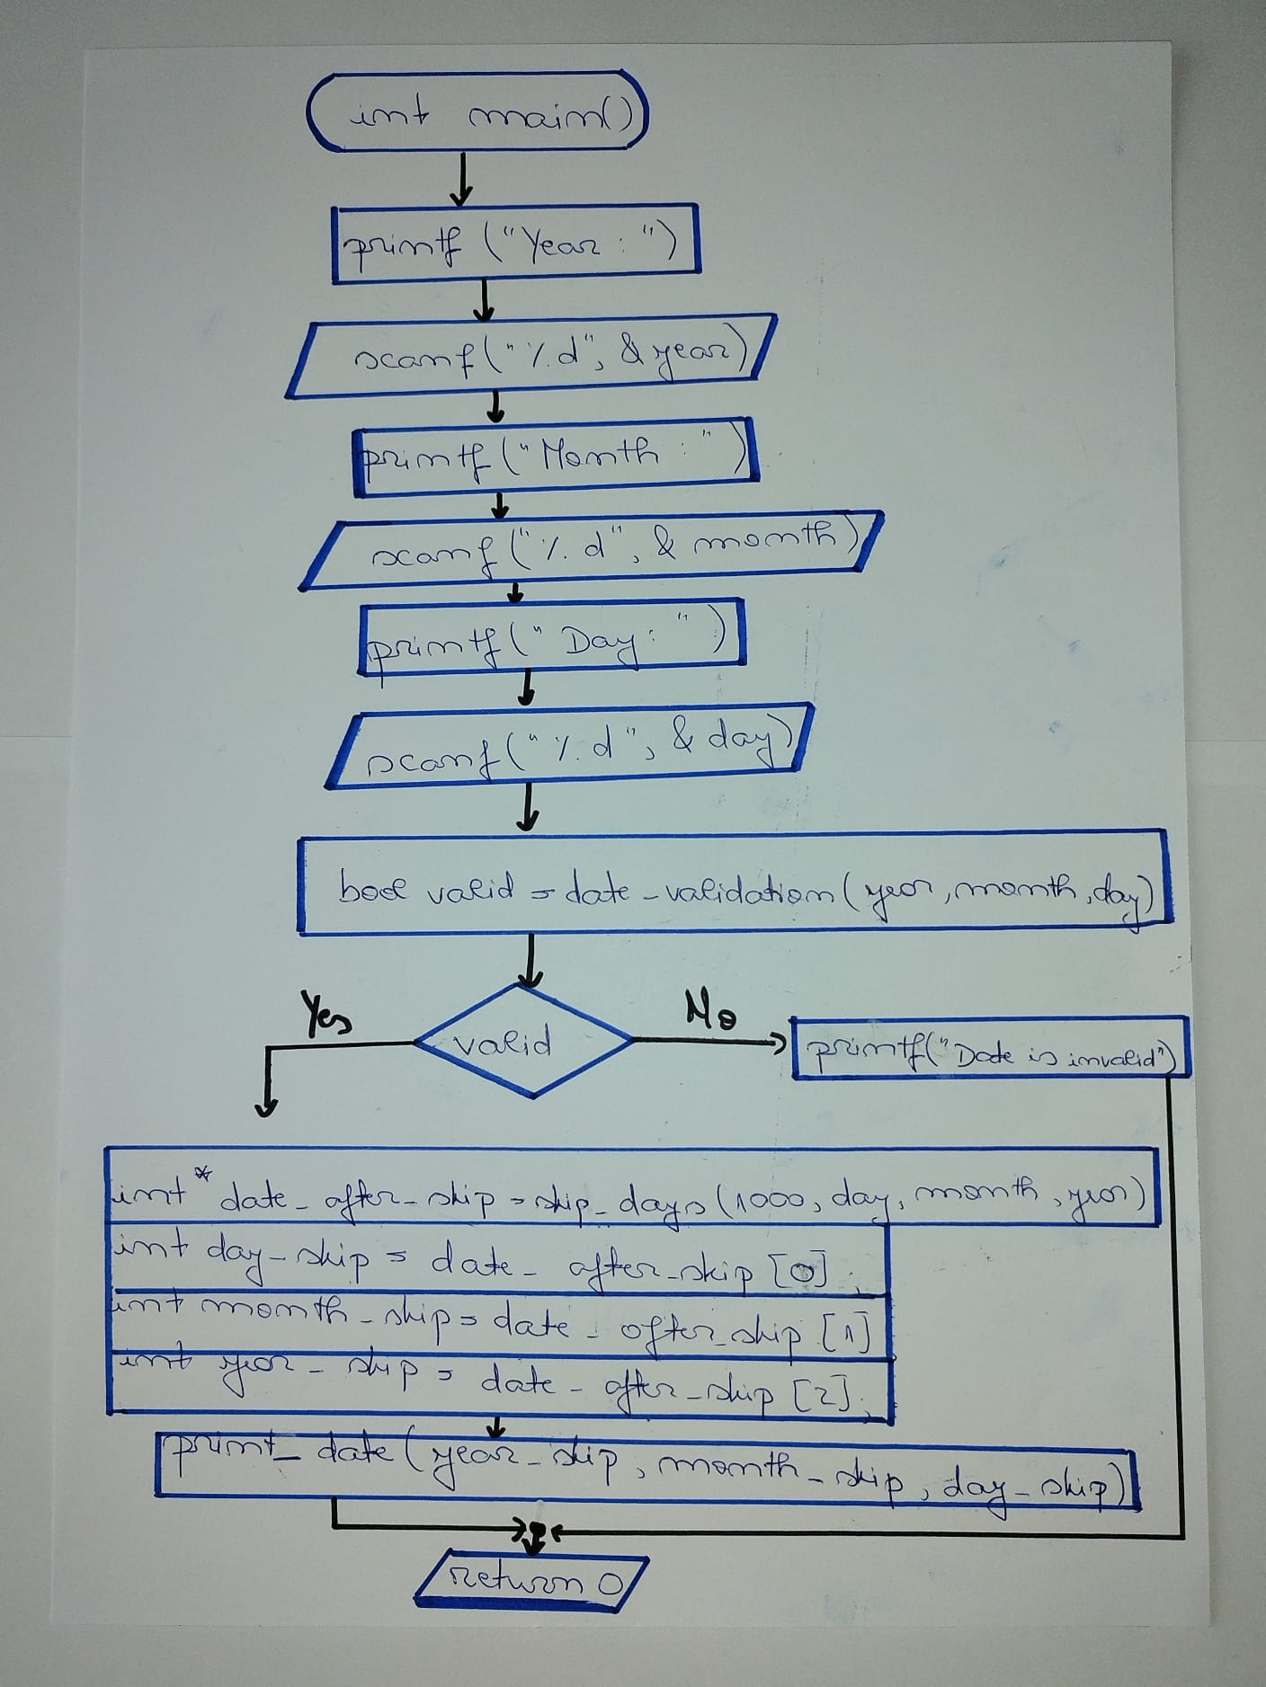

Listing for the entire program ( with useful comments)

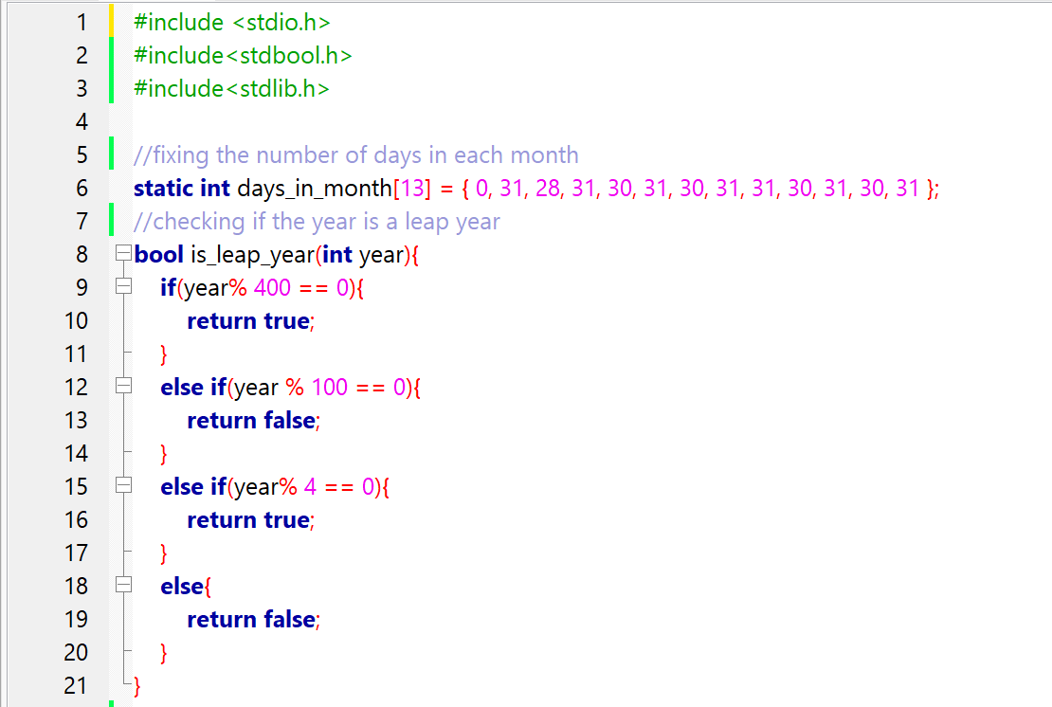

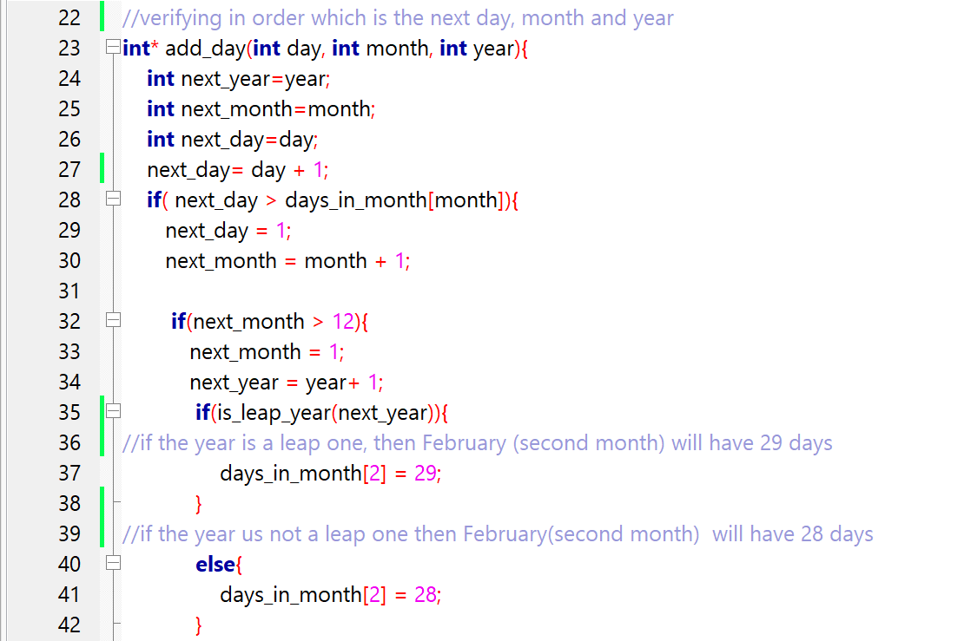

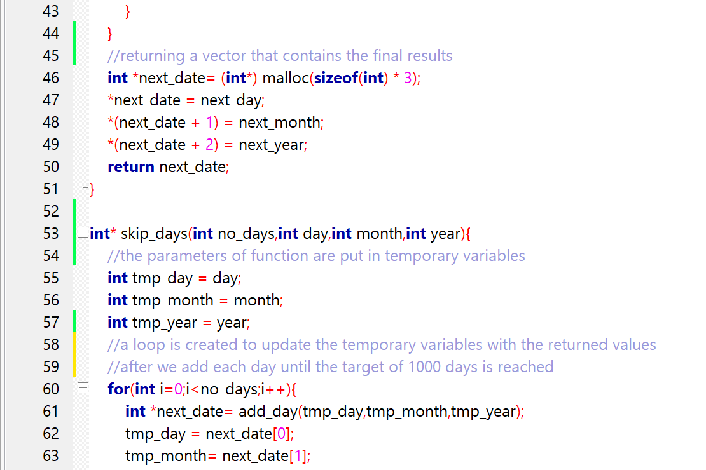

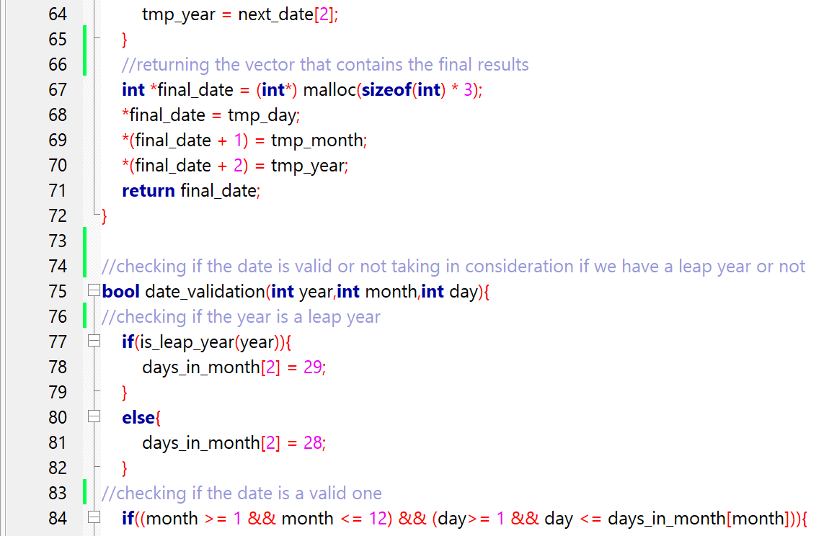

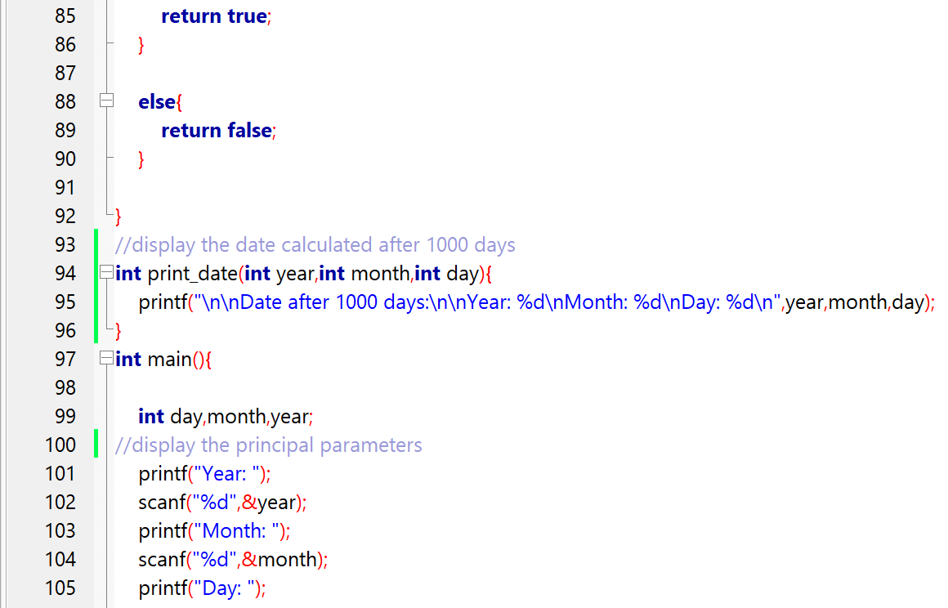

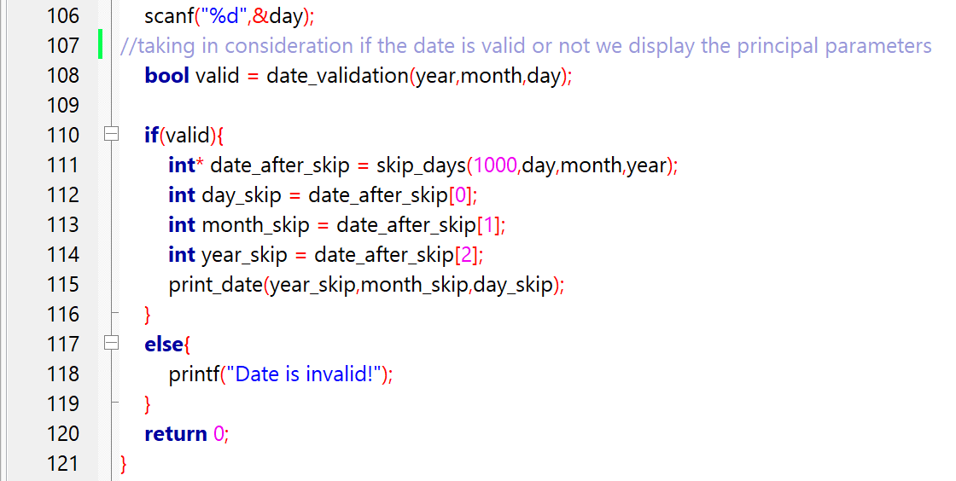

Instances of running the program (screenshots)

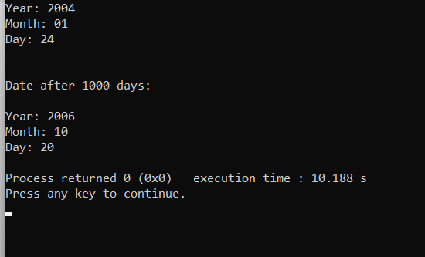

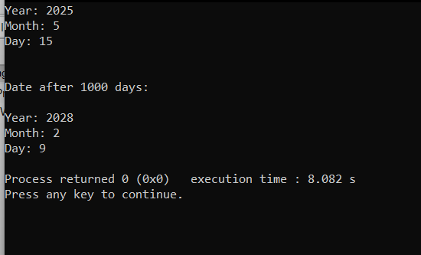

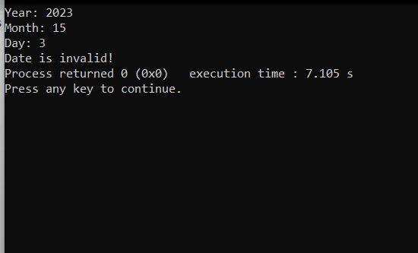

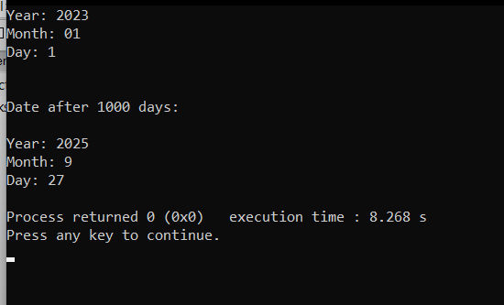

**Bibliography**

<https://www.codingeek.com/tutorials/c-programming/example/check-leap-year/#:~:text=C%20Program%20to%20check%20Leap%20year%201%20Initially%2C,leap%20year%20or%20not%20is%20verified.%20More%20items>

<https://www.geeksforgeeks.org/bool-in-c/>

<https://learn.microsoft.com/en-us/dotnet/csharp/language-reference/builtin-types/bool>

<https://www.geeksforgeeks.org/c-pointers/>

<https://www.tutorialspoint.com/cprogramming/c_pointers.htm>